Experiment No. 1

Comparative Study of Low-Code Development versus Traditional Application Development Approaches

1. Aim
To study and compare the Traditional Application Development approach with the Low-Code Development approach based on their development process, development time, coding requirements, flexibility, cost, and deployment efficiency.

2. Introduction to Traditional Application Development
Traditional application development is the conventional method of building software applications where developers write the entire source code manually using programming languages such as Java, Python, C#, JavaScript, or PHP. This approach requires a deep understanding of programming concepts, software architecture, databases, testing methodologies, and deployment techniques.
The Software Development Life Cycle (SDLC) is commonly followed, which includes stages such as requirement analysis, system design, coding, testing, deployment, and maintenance. Traditional development provides complete control over application functionality and customization, making it suitable for large-scale and complex enterprise applications. However, it requires experienced developers, longer development time, and higher development costs.
Advantages
- Highly customizable
- Better performance and scalability
- Suitable for complex business applications
- Full control over source code
Disadvantages
- Time-consuming
- Requires skilled programmers
- Higher development and maintenance cost
- Longer testing and deployment cycles

3. Introduction to Low-Code Development
Low-code development is a modern software development approach that enables applications to be built using graphical user interfaces (GUI), drag-and-drop components, visual workflows, and minimal hand-written code. It significantly reduces the amount of manual programming required and accelerates application development.
Low-code platforms provide pre-built templates, reusable components, automated workflows, and database integration, allowing both professional developers and business users (citizen developers) to create applications quickly. Popular low-code platforms include OutSystems, Mendix, Microsoft Power Apps, Appian, and Zoho Creator.
Low-code development is widely used for developing internal business applications, workflow automation, customer relationship management (CRM), and rapid prototyping.
Advantages
- Faster application development
- Minimal coding required
- Lower development cost
- Easy maintenance and updates
- Rapid deployment
Disadvantages
- Limited customization
- Platform dependency
- Licensing costs
- Not suitable for highly complex applications
4. Diagram
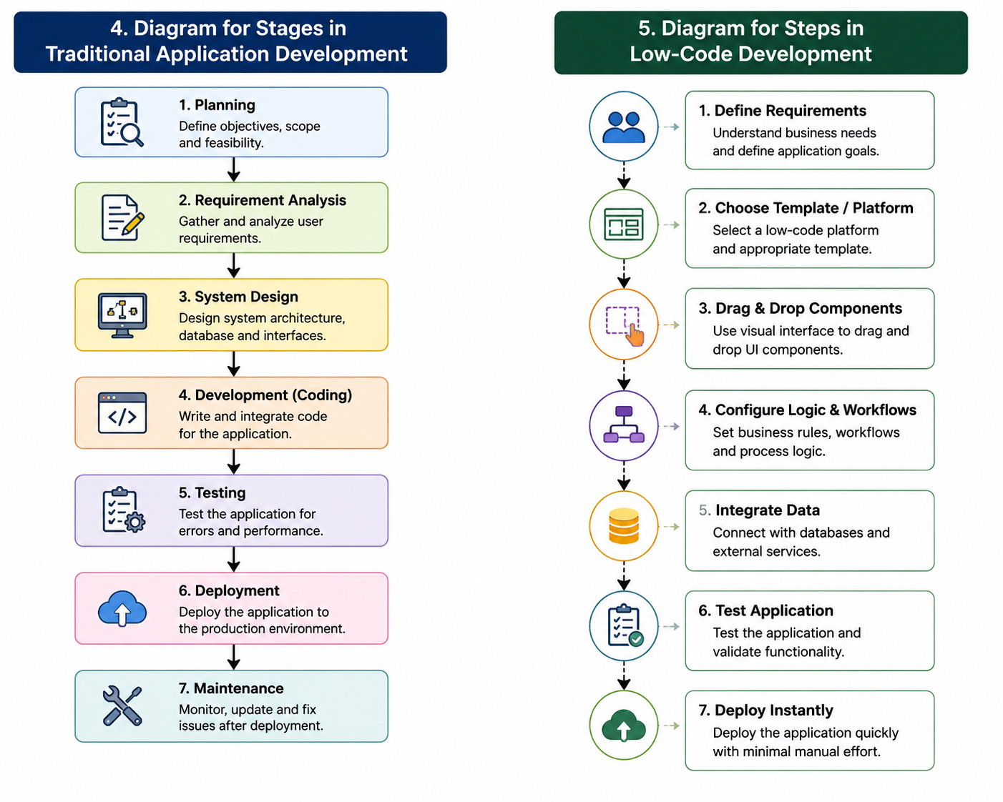

5. Comparative Analysis
Parameter | Traditional Development | Low-Code Development
Coding | High | Low
Development Speed | Slow | Fast
Cost | High | Lower
Customization | High | Moderate
Development Time | Longer | Shorter
Maintenance | Complex | Easier
Technical Skills | Advanced | Basic to Moderate

6. Result
The comparative study shows that Traditional Application Development provides greater flexibility, customization, and control, making it suitable for large and complex software systems. However, it requires significant coding expertise, more development time, and higher costs.
In contrast, Low-Code Development enables faster application development with minimal coding effort, reduced costs, and quicker deployment. It is ideal for rapid application development, business process automation, and organizations that require faster time-to-market. Therefore, the choice between traditional and low-code development depends on the complexity, customization requirements, budget, and development timeline of the project.

